**MED TAKE BACK**

***21st in Adams County***

SATURDAY * APRIL 24th

10:00 AM to 2:00 PM

9 FREE Medication Collection Sites ­­­­­­

LITTLESTOWN

*Alpha Fire Co. #20

**Host: Littlestown Borough Police**

MCSHERRYSTOWN

*Moose Lodge #720

**Host: McSherrystown Borough Police**

NEW OXFORD

*Eastern Adams Regional Police

**Host: Eastern Adams Regional Police**

YORK SPRINGS

*Bermudian Springs School District

**Hosts: Latimore Township Police & East Berlin Borough Police**

BIGLERVILLE

*Biglerville Hose & Truck Co. #1

**Host: Biglerville Borough Police**

GETTYSBURG

*Adams County Housing Authority

**Hosts: Gettysburg Borough & Cumberland Township PDs**

**\*Gettysburg PA State Police Barracks**

**Host: PA State Police, Troop H**

CARROLL VALLEY

*Greater Carroll Valley Community and Education Complex

**Hosts: Carroll Valley Borough Police &**

**Liberty Township Police**

HANOVER

*Conewago Township Police

**Host: Conewago Township Police**

.

*Safely dispose of unused, unwanted,*

*or expired prescriptions and*

*OTC (over the counter) medications:*

*loose pills, liquids, creams, and pill packs.*

***Safe for you. Safe for the environment.***

**NO NEEDLES, SHARPS, or INTRAVENOUS SOLUTIONS.**

**\*Dispose of Needles/Sharps in kiosk located @ Bonneauville FD/EMS**

**\*24/7...Year Round!\***

PET MEDS Welcome!



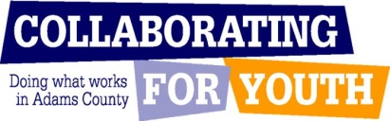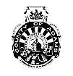

For more information, contact

Eileen Grenell…

**Call: (717) 357-4439**

**Email:** [**acsaprevention@cfygettysburg.com**](mailto:acsaprevention@cfygettysburg.com)

**or Visit:** [**www.cfygettysburg.com**](http://www.cfygettysburg.com)

**Connect with us on Facebook**